Homework 2

“An Aggie does not lie cheat or steal or tolerate those who do”

1.

1. (**SELECT** *maker, model, type* FROM *Product* WHERE *maker* = ‘G’) **UNION** (**SELECT** *maker, model, type* FROM *Product* WHERE *maker* = ‘H’)

A = {tuple of maker G: (g1)}

B = {tuples of maker H: (h1,h2)}

A U B

2.

ShipsDB Creation Server Output

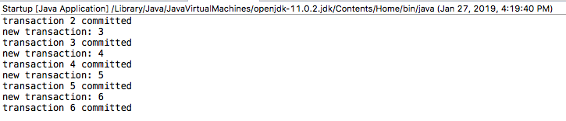

ShipsDB Creation Client Output



3.

1. select SId, Sname from student;
   * Gets all of the Id’s and names corresponding to them from the student table in numerical order in respect to the SId
2. select EId from section, enroll;
   * Gets all of the Eid’s from the section and then enroll. Enroll is the inner loop
3. select EId from enroll, section;
   * Gets all of the Eid’s from the enroll table. Section is the inner loop.
4. select Title, SectId from course, section where CId=CourseId and Prof='turing';
   * Gets the title and section Id from tables course and section where the professor is named “turing” and the course ID of the course table is equal to the course ID from the section table
5. select SName,GradYear from student, dept where MajorId = DId and DId=20;
   * Gets the graduation year and names of the students whose majorId from the student table is equal to the department ID in the department table, and the department ID is equal to 20.
6. select SName,GradYear from student, dept where MajorId = 20;
   * The results are not the same as the query above. Each student that showed up only once in the previous query now shows up 3 times. This is because there is an entry in both the student and department tables with different values but the same names. The constraint from the above query is not in this one.

4. Work textbook exercise 2.4.3 (p.55) by the writing relational algebra using MS Word equation editor for parts b, c, and e. Also draw an expression tree for parts c and e.

1. Πname(σlaunched<1921(Ships))
2. Πship(σbattle=Denmark Strait AND result=sunk(Outcomes))
   1. Project: name  
      ↓  
      Select: battle = Denmark Strait AND result = sunk

↓  
Outcome

1. Πname,displacement,numGuns(Classes × (Ships ×name=ship (σbattle=Guadalcanal(Outcomes))))
2. Project: name, displacement, numGuns
3. ↓  
   Join: Classes & Ships  
   ↓  
   Join: A.name = B.ship
4. ↓ ↓
   1. Rename: Classes & Ships Join, A Rename: Outcomes, B
   2. ↓ ↓
5. Classes & Ships Join Outcomes

5. Work textbook exercise 2.5.2 (p.63) part b.

* Πclass(σnumGuns>9 AND bore>14(Classes)) = Ø

6. Write SQL statements for DERBY ij for exercise 2.4.1 (p.52) parts a, b, and c. Turn in the ij console input and output showing your SQL and its output.

1. select model from pc where speed >= 3.00;
2. select maker from laptop, product where product.type = ‘laptop’ and product.model = laptop.model and laptop.hd >= 100;
3. select pc.model, price from pc, product where product.maker='B' and product.model = pc.model union all select laptop.model, price from laptop, product where product.maker='B' and product.model = laptop.model union all select printer.model, price from printer, product where product.maker='B' and product.model = printer.model;

Derby Output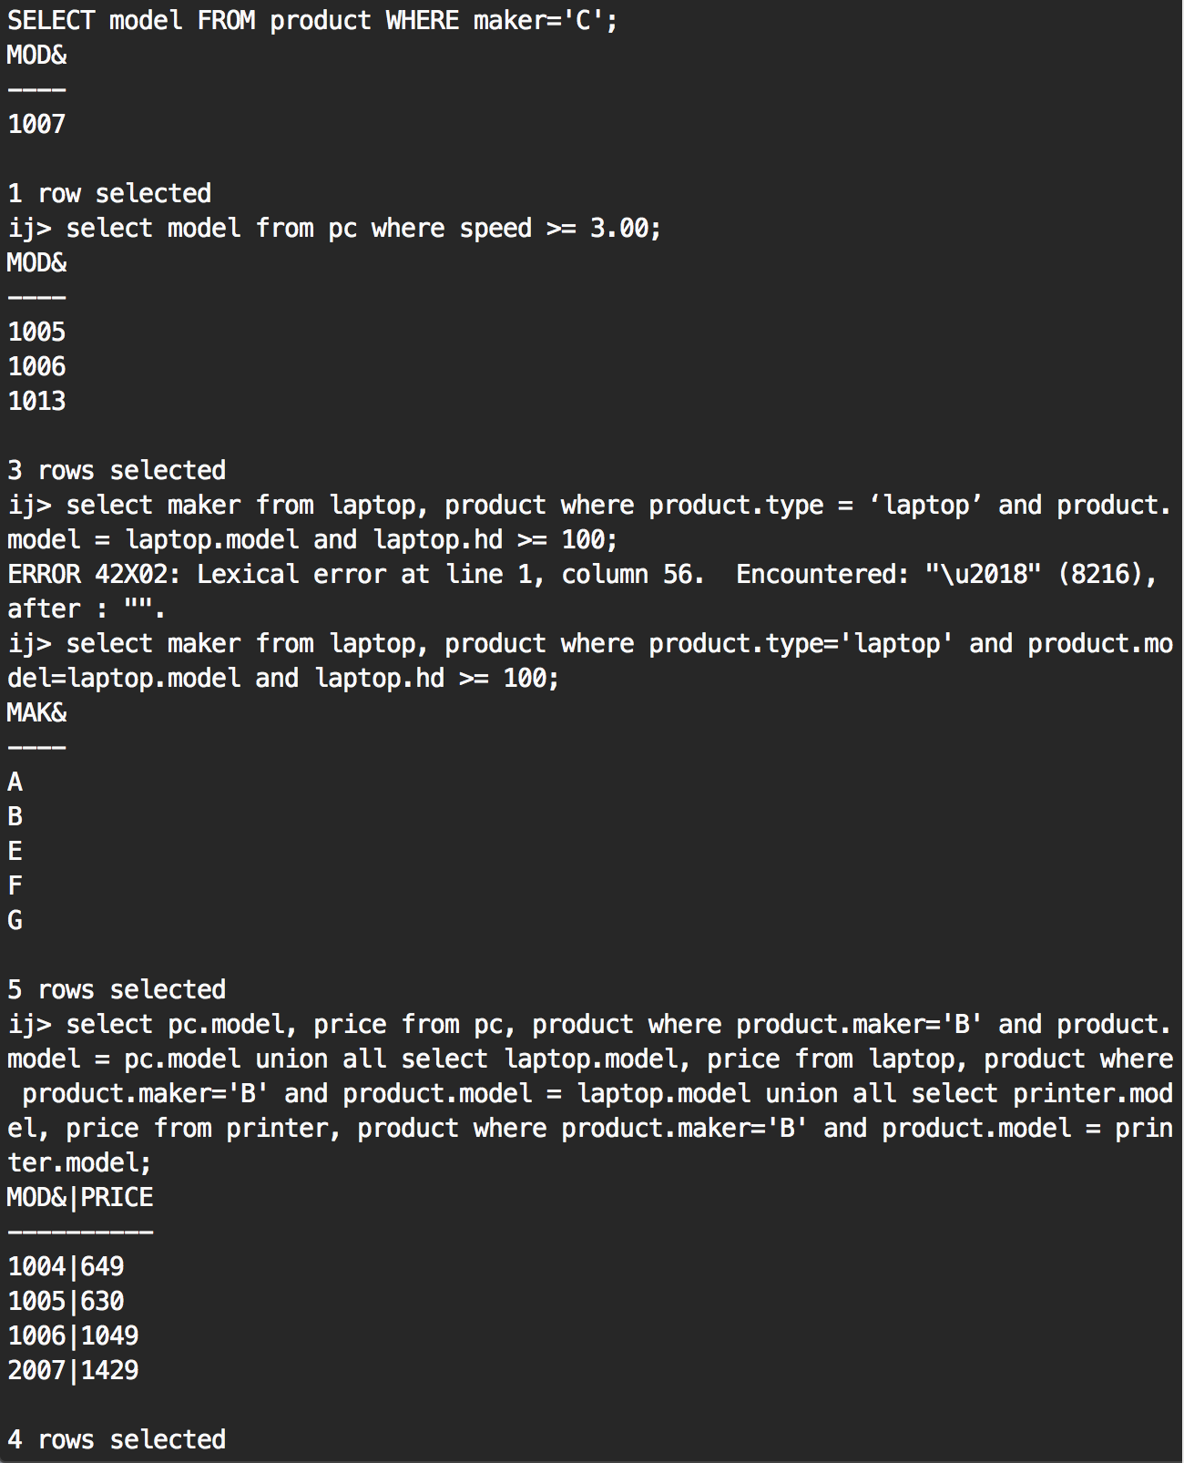

7.

ShipDB Server Output

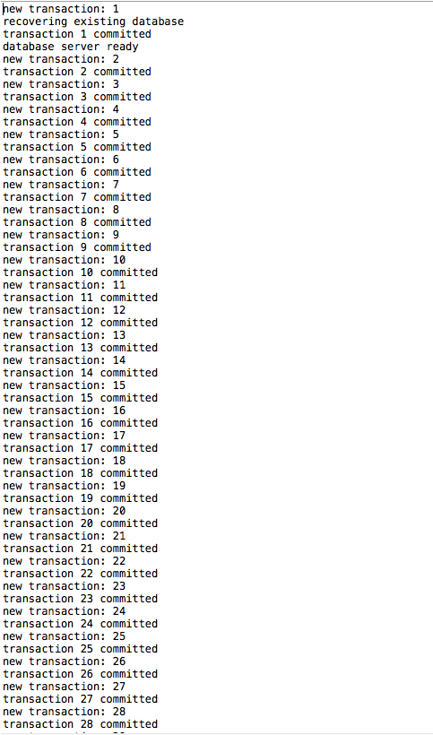

ShipsDB Interpreter Console Output

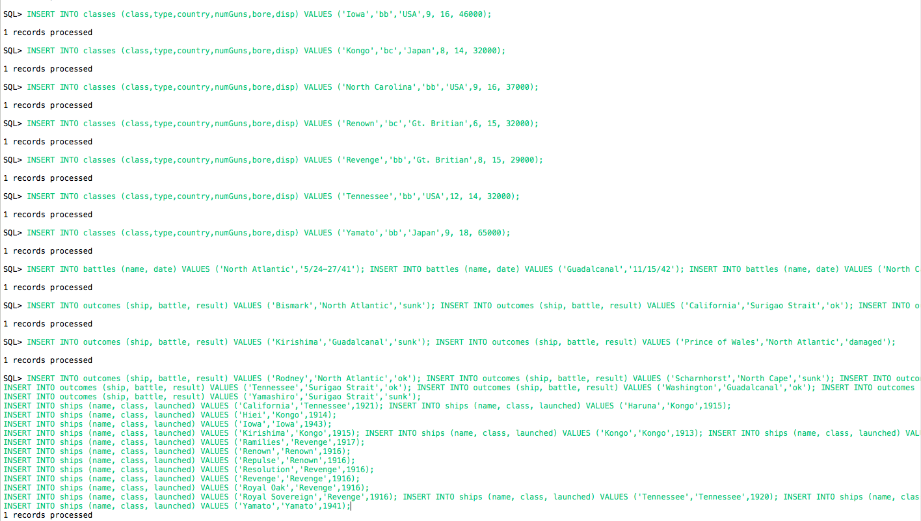

8.

1. Define the term Functional Dependency as it applies to attributes in a single table. Give an example using the ENROLL table discussed in class.
   1. A functional dependency is a constraint that describes the relationship between attributes in a relation.
2. What makes a functional dependency trivial?
   1. A functional dependency FD: *X* → *Y* is called *trivial* if *Y* is a [subset](https://en.wikipedia.org/wiki/Subset) of *X*.
3. Assume a relation R(A,B,C,D) with primary key AB is in the 1st normal form, but not 2nd normal form. Give at least three potential FD’s that determine only part of a row
   1. AB → C, B → D, and A → C
4. What if R above is in 2nd normal form, but not 3rd normal form. Give an example FD that prevents R from being in 3rd normal form.
   1. C → D
5. What if R has a key AB. What FD must be true for R to be in BCNF?
   1. AB → CD
6. Assume R has the FD’s: A→ ABCD and C→D, the last of which causes a violation of 3rd normal form. Decompose R into two relations R1 and R2 that are in 3NF. What attributes of R are in R1 and what attributes of R are in R2?
   1. R1(A,B,C) and R2(C,D)
7. SQL permits arithmetic like Select A*D from R; Given that information and R1 and R2 from part F, write a select statement using JOIN that returns A*D.
   1. SELECT R1.A*R2.D FROM R1 INNER JOIN R2 ON R1.C=R2.C

9. Exercise 3.2.2, b and c, for part i relation S(A,B,C,D), p.83

1. A
2. AB, AC, AD, ABC, ABD, ACD, ABCD

10. Given R(A,B,C,D,E) and FDs: A→B, BC→E and DE→A, explain why ABCDE, ABCD and BDE are not candidate keys, and why ACD is (See p. 72).

* ABCDE, ABCD, and BDE are not the minimal sets that can uniquely identify a tuple without referring to any other data. The candidate keys are ACD, BCD, and CDE.

11. Exercise 3.5.2, p. 105, is relation COURSES(C,T,H,R,S,C) in 3rd normal form? BCNF? Explain.

* The relation isn’t in 3rd normal form. This is because the only key is HS. Because of this, none of the other FD’s RHS are keys. Its not in BCNF either since it is not in 3rd normal form.

12. Using the SQL in #2 and #7 above, create the shipsDB using Derby. Turn in a screen shot of a side-by-side comparison of the shipsDB folder using SimpleDB vs the shipsDB folder using Derby. What’s the main take away about DBMS file storage after your inspection of the two folders?

* The picture of the 2 systems is below. Derby has a more complicated and robust file system. SimpleDB database structure is literally just the tables which contain their own rules for the tables. Derby is generally better and more thought out.
* 